Home Page



Easy to use nav bar with all the appropriate links to each page. Consistent on every page.

Logo will be placed here

User login details for booking tickets

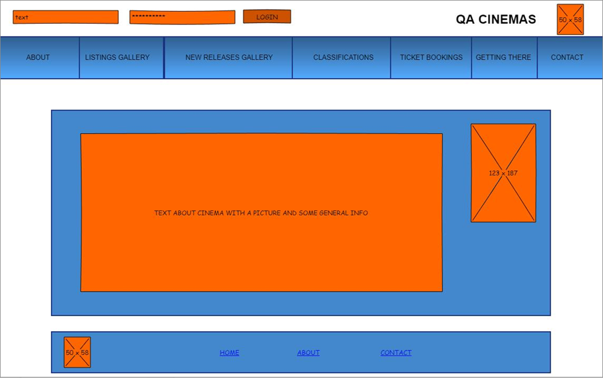

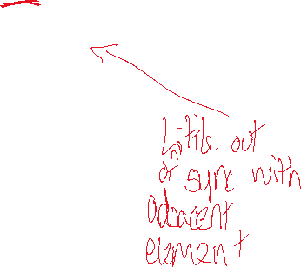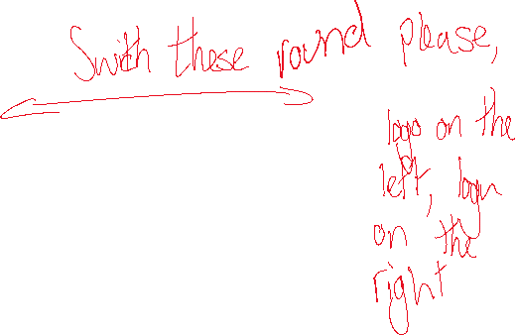

Picture of the cinema to evoke the cinematic experience

Footer containing ‘home;, ‘about, and ‘contact’ nav links to each page. Consistent on every page.

General information about the cinema. This communicates to the viewer the purpose of the site.

Listings Gallery

Supporting text which gives a brief overview of the movie’s story.

Movie title displayed with the age rating directly next to it

Image of the movie poster

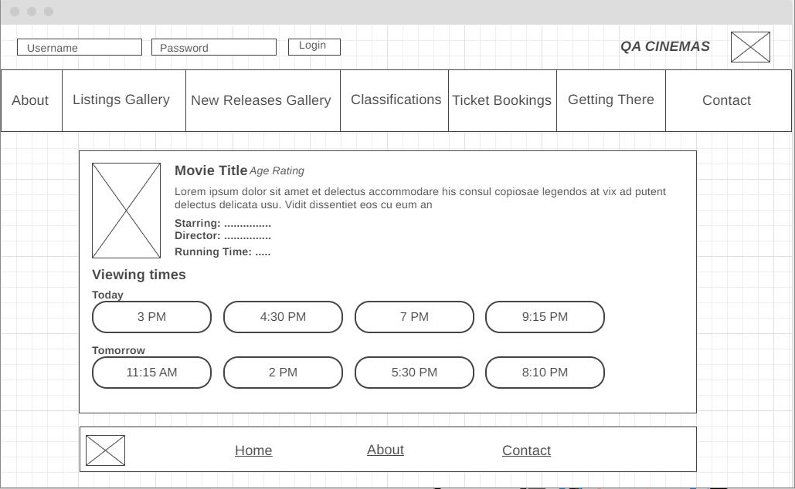

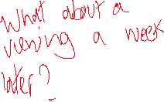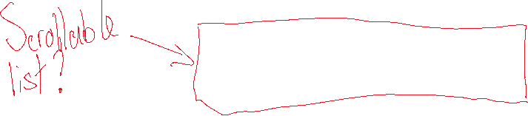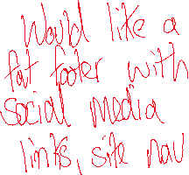

Some more supporting text which displays which actors are in the movie, who directed the movie and how long the movie will run for.

Viewing times to display when the movie will be played.

New Releases Gallery

Almost exact same layout as the listings gallery page.

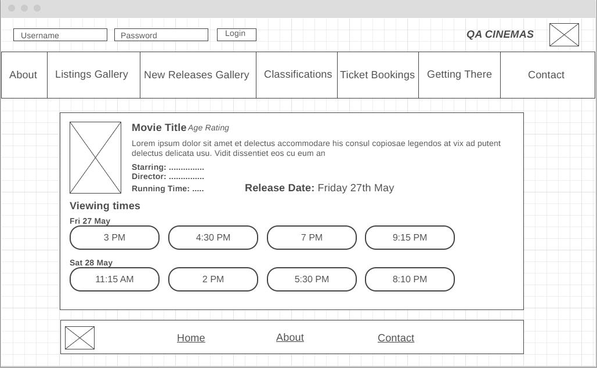



Shows the release date of the movie.

About Page

About us page has links to the company social media accounts such as Twitter handle, email address, blog, etc.

Names and a little info about the team

Links to contact page to find company details

Image showing creators of the cinema

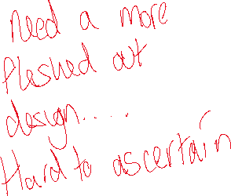

Classifications Page



Link takes you to classification pages which gives further explanation of classifications

Images of classification logos to give visual content

Rules and terms to do with the classifications.

E.g. 15: Horror

Page explains the film classifications and rating

Ticket Bookings Page

Screening date selection

Screening time selection

Number of adult, child and concession tickets

Total number of seats and price of booking

Booker name detail submission

Name of film

Image of film being shown

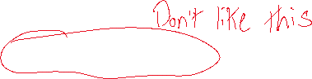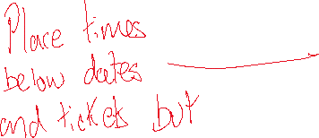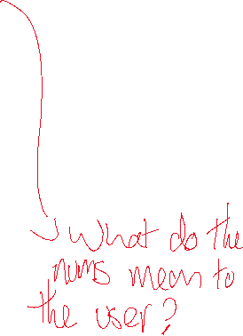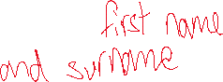

Getting There Page

Image of direction on how to get to cinema parking



Image of cinema to show how it looks

Address to get to the cinema

Description to cinema using transport (bus/train stations)

Google search engine to find the cinema

Contact page wireframe

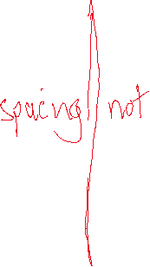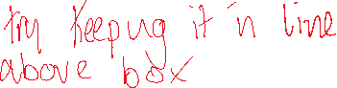

The overall style of the page will follow the rest of the site and will have both contact information and an email contact form to send an email to the site owner.

The requirements met:

* The contact page is part of the overall navigation in the navbar and footer
* The page has a way to contact the site owner electronically in the form of an email contact form
* The page will include an address of a QA facility (currently Lorem ipsum text)
* The email form has the name and email address fields of the user along with the subject and message field for the email sent

